PCA Standardization

User | Movie1_Toy-Story | Movie2_MonstersInc.
1 | 4 | 5
2 | 2 | 3
3 | 3 | 4
4 | 5 | 4
5 | 5 | 5
 | Mean = 3.8 | Mean= 4.2
 | Sdev= 1.303840481 | Sdev= 0.836660027

Standard deviation can be calculated manually or using excel/R.

Standardize the data using the below formula:
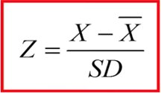
User | Movie1_Toy-Story | Movie2_MonstersInc.
1 | 0.153392998 | 0.956182887
2 | -1.38053698 | -1.43427433
3 | -0.613571991 | -0.239045722
4 | 0.920357987 | -0.239045722
5 | 0.920357987 | 0.956182887
 | Mean =0 | Mean =0
 | Sdev = 1 | Sdev = 1

Now use R to calculate the PCA weights and write the PCA equations:
Component Matrix:
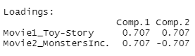
PC1 = 0.707* Movie1 + 0.707 Movie2
PC2 = 0.707* Movie1 + (-0.707 * Movie2)

Calculate the scores for PC1 and PC2:
Mean=0 | Mean=0
Sdev=1.32 | Sdev =0.52
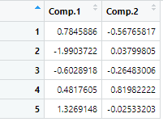

Now standardize the PC1 and PC2 to get standardized PCA scores:

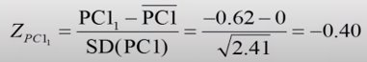

Mean=0 | Mean=0
Sdev=1 | Sdev =1
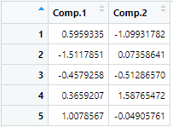

Selecting the components:
Calculate the %var and Cum% variance on non standardize PCA scores
Var=1.74 | Var=0.27
%var=86.6% | %var=13.4%
Cum%=86.6% | Cum%=100%


For this select only PC1 as it has more variance greater than 1.

